**Practical 3 | Shopping_ Trends | SQL Snowflake Query**

1. **All records where size is missing and purchase is greater than 50.**

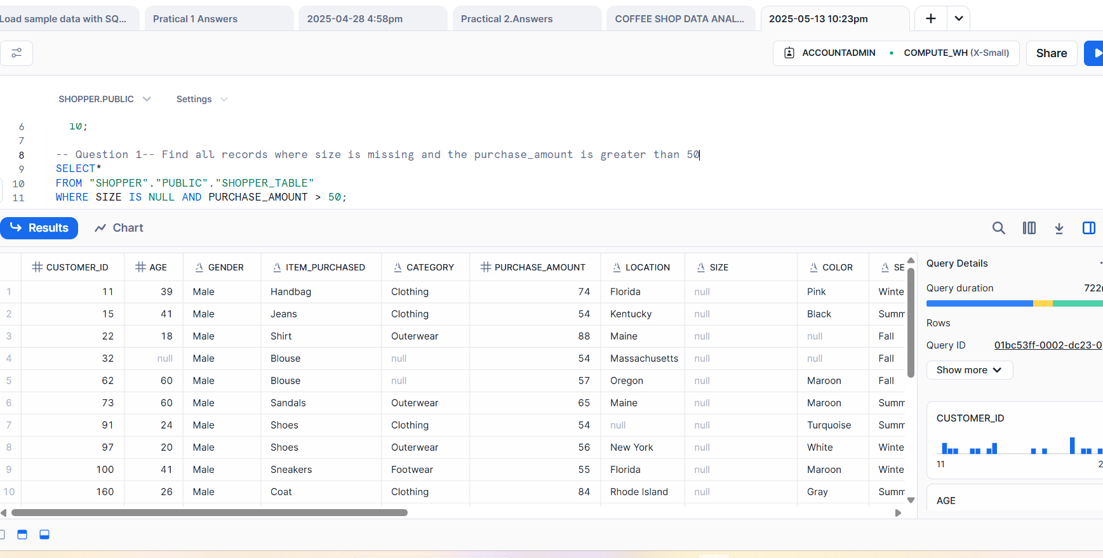

**Q1 continues…..**

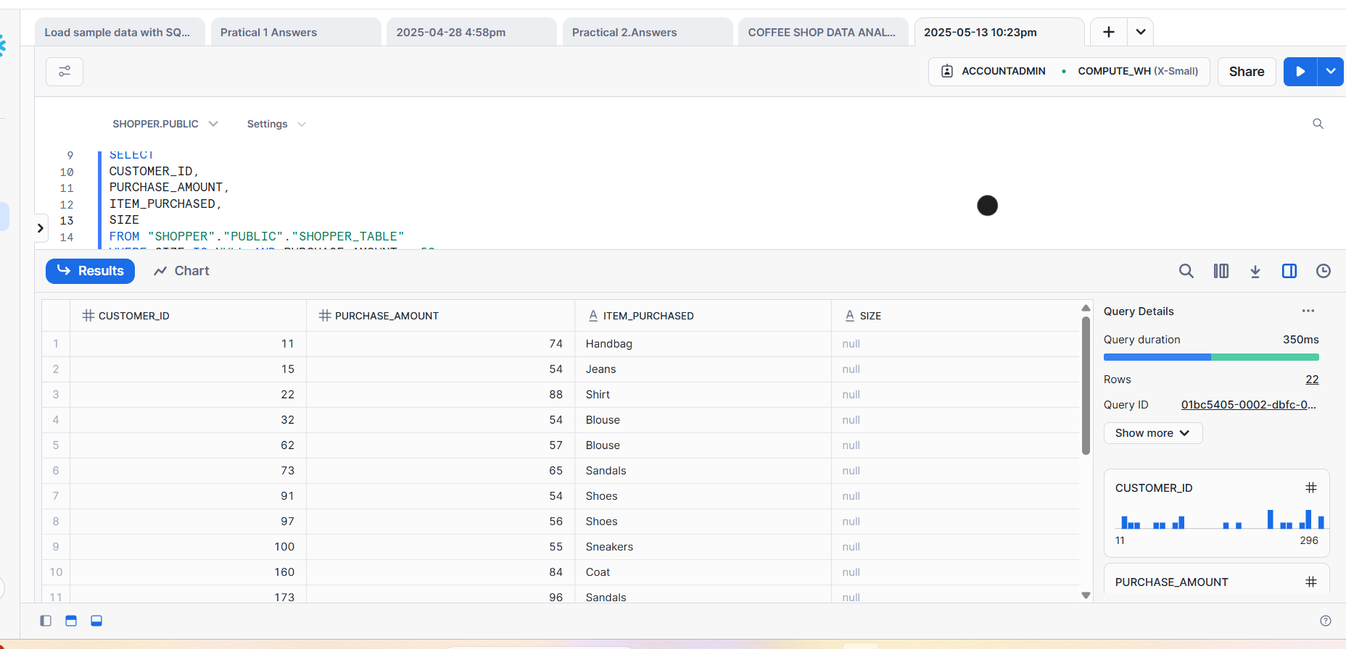

**2.Total number of purchases GROUPED BY season,treating NULL values as UNKNOWN season.**

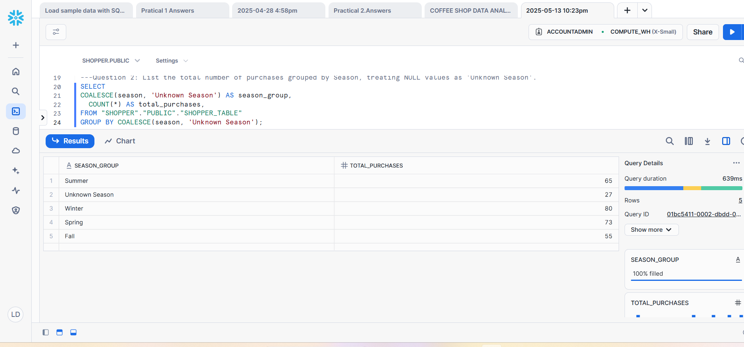

**3.Customers that used each payment method , treating NULL as not provided.**

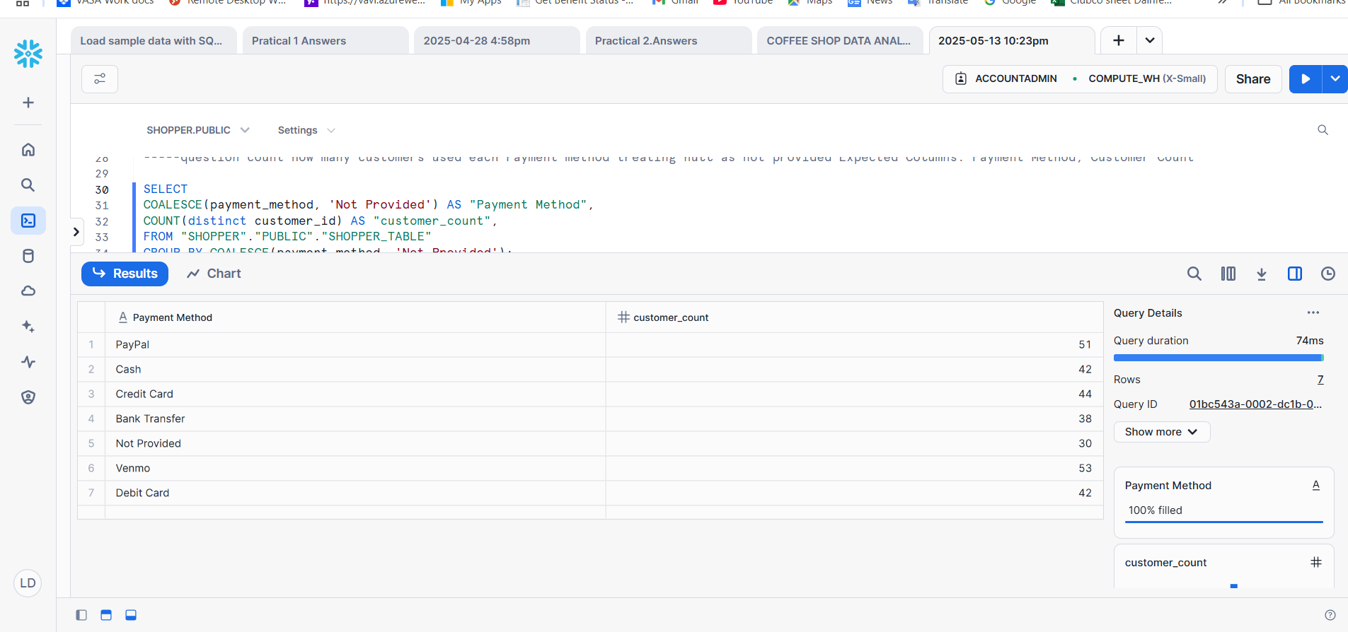

**4 . Customers where Promo code used is NULL and Review rating is below 3.0**

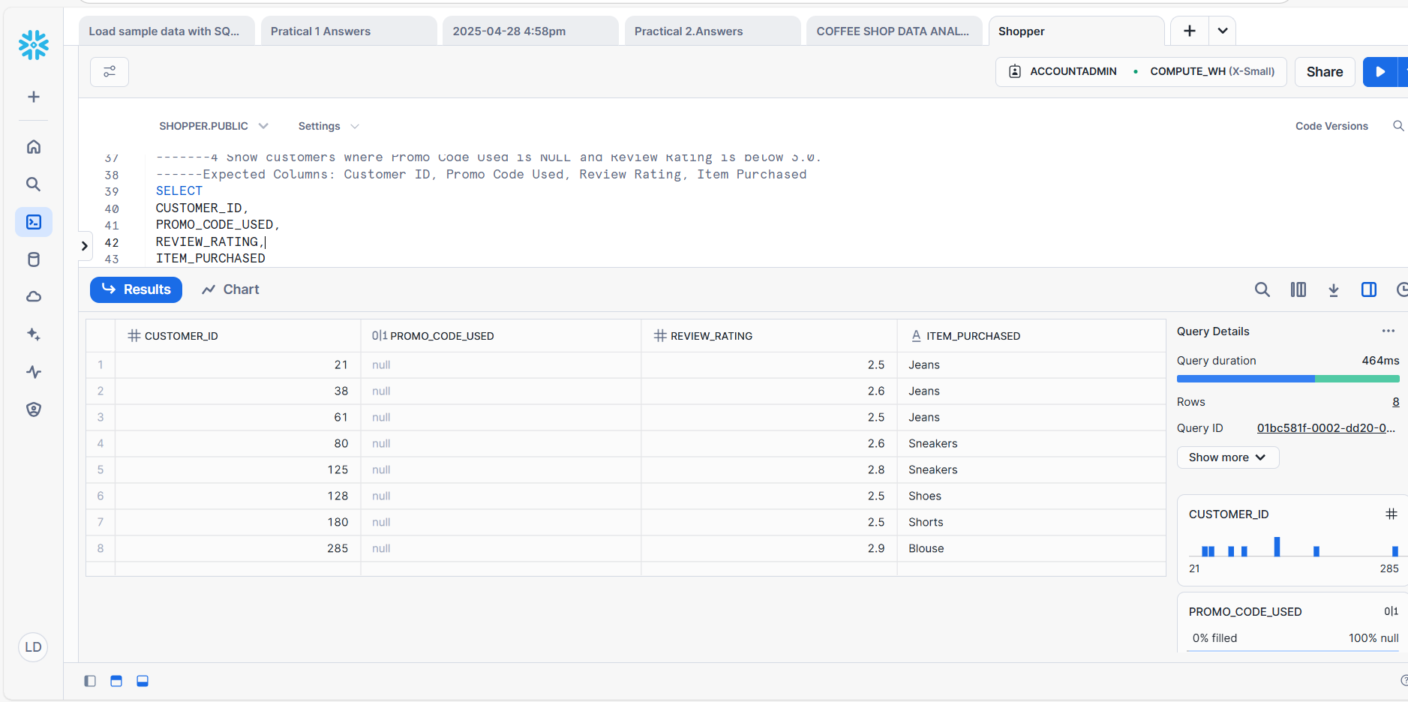

5.GROUP BY customers by shipping type and return average purchase_amount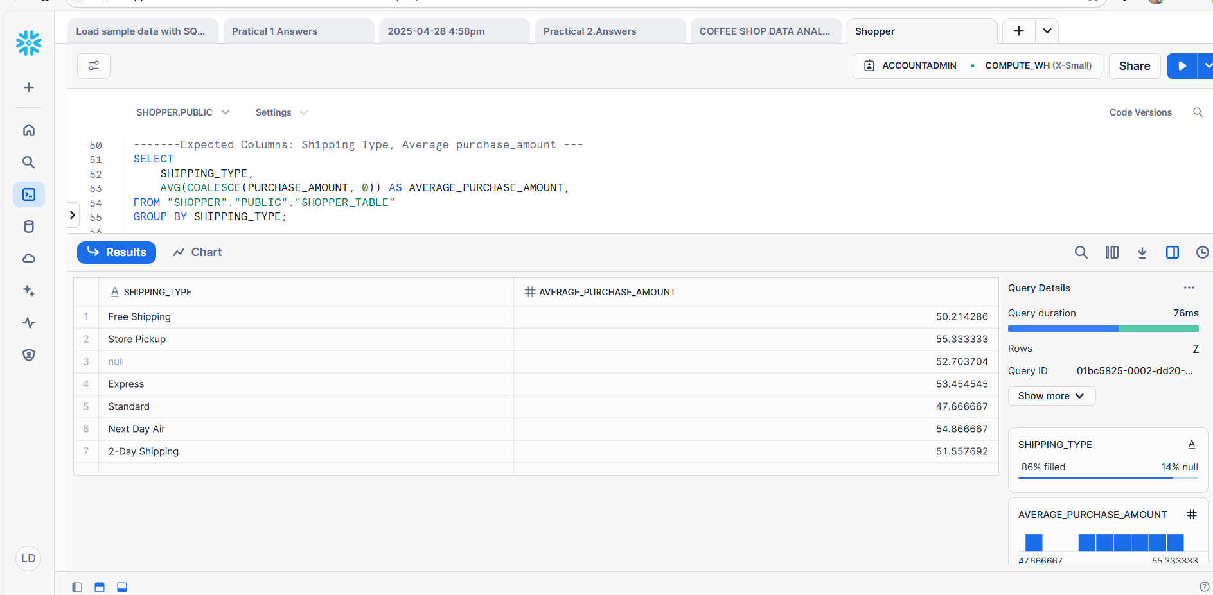

6.Purchases by location

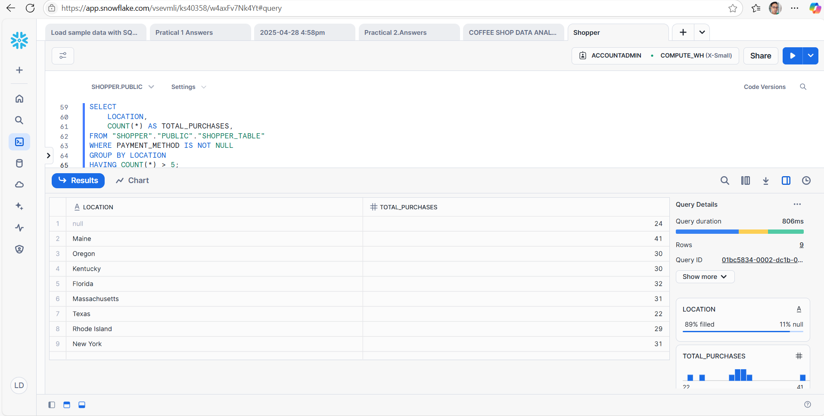

7. New Column as Spender category

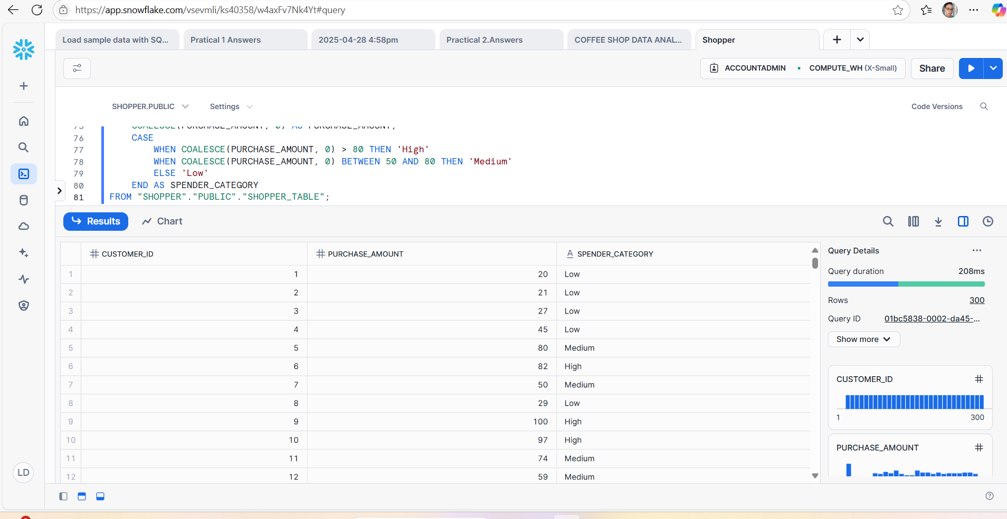

8.Customers with NO previous purchases with Color NOT NULL.

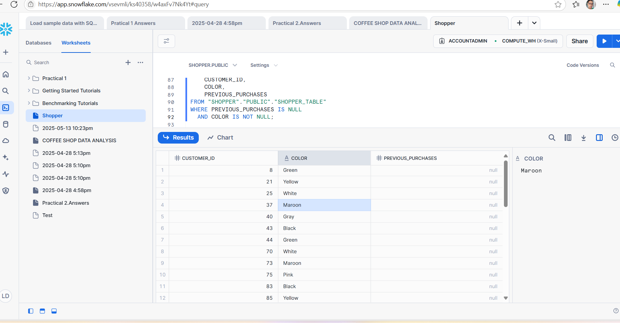

9. GROUP BY Frequency of Purchases and show the total amount spent per group, treating NULL frequencies as 'Unknown'.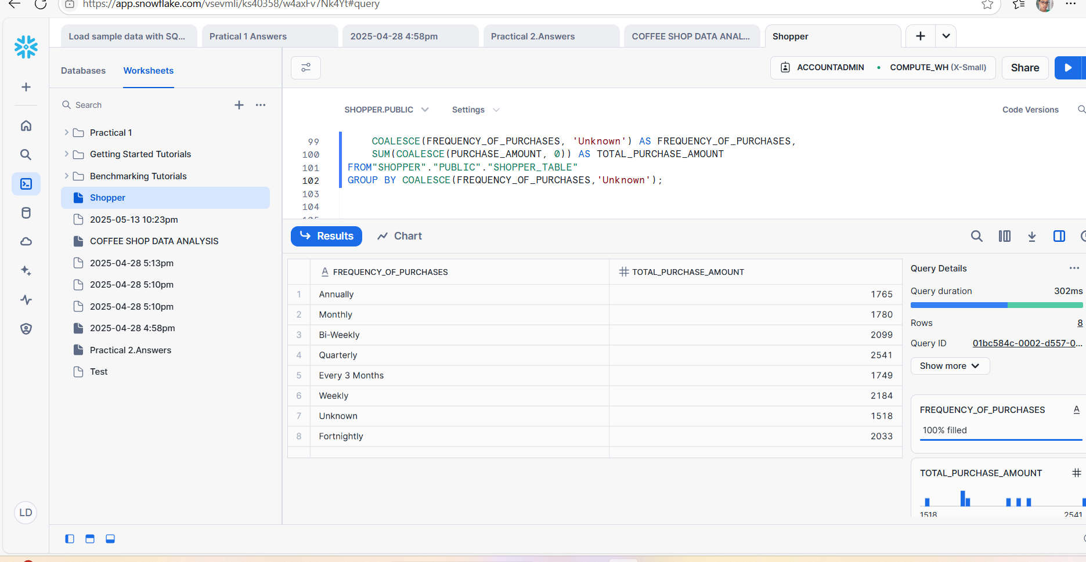

10. List of ALL Category values with the number of times each was purchased, excluding rows where Category is NULL.

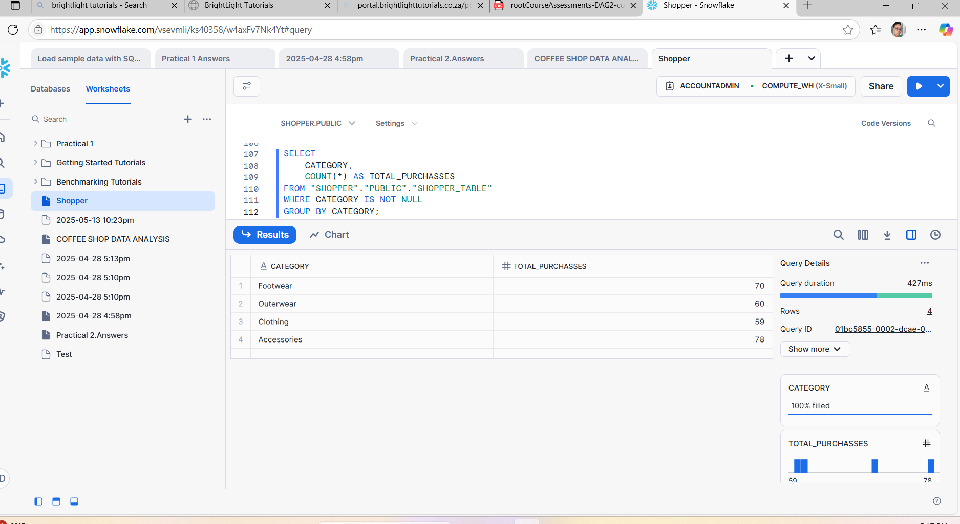

11. Return the top 5 Locations with the highest total purchase_amount, replacing NULLs in amount with 0.

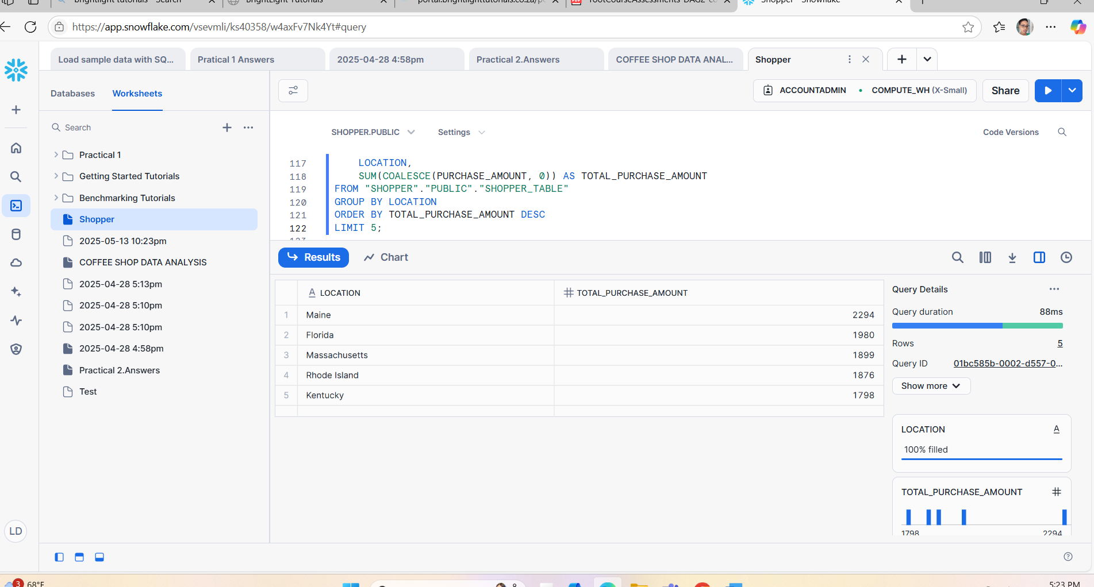

12.. Group customers by Gender and Size, and count how many entries have a NUL L Color.

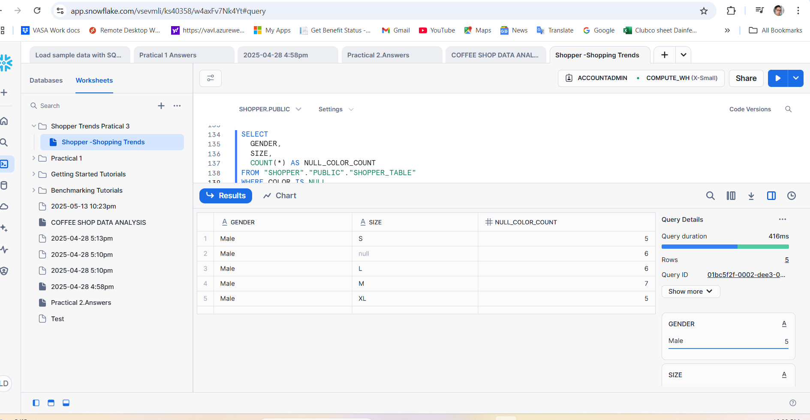

13. Purchases where more than 3 purchases had NULL Shipping Type. 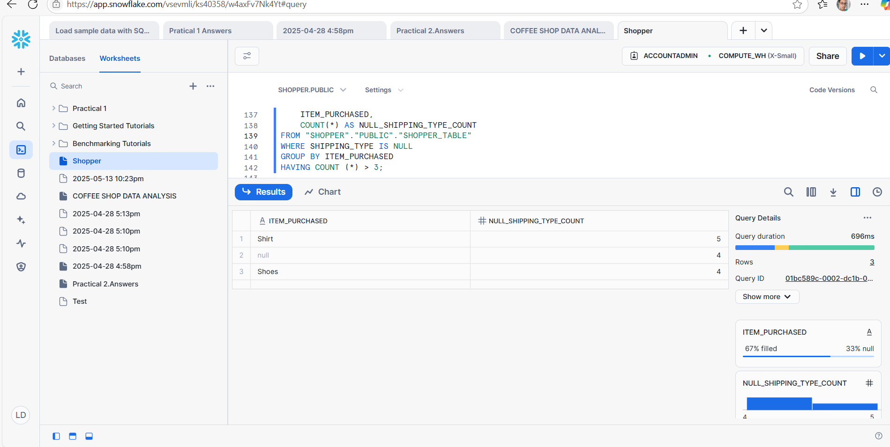

14. Show a count of how many customers per Payment Method have NULL Review Rating. Expected Columns: Payment Method, Missing Review Rating Count

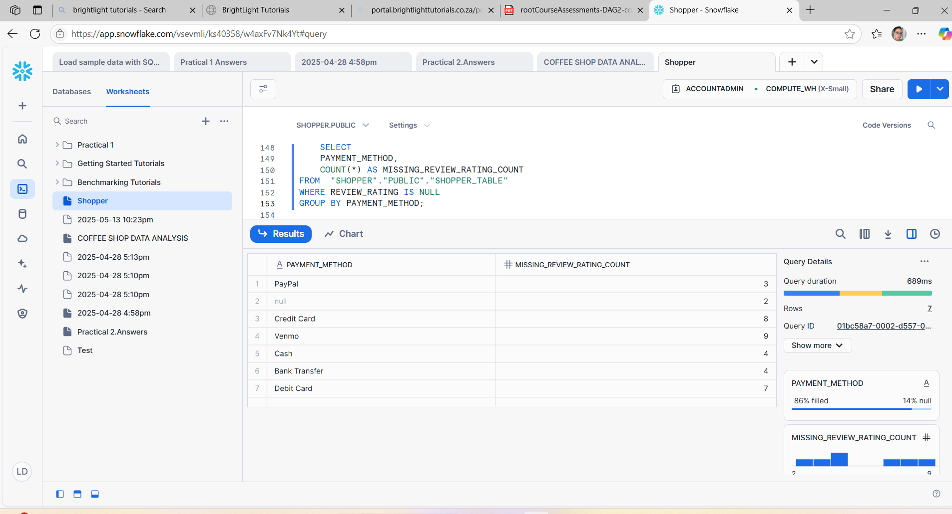

15. Group by Category and return the average Review Rating, replacing NULLs with 0, and filter only where average is greater than 3.5.

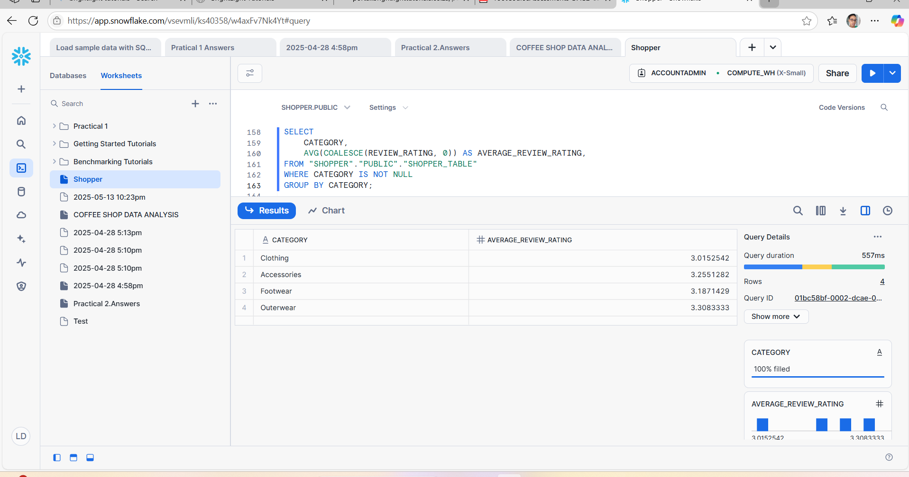

16. Listing all Colors that are missing (NULL) in at least 2 rows and the average Age of customers for those rows.

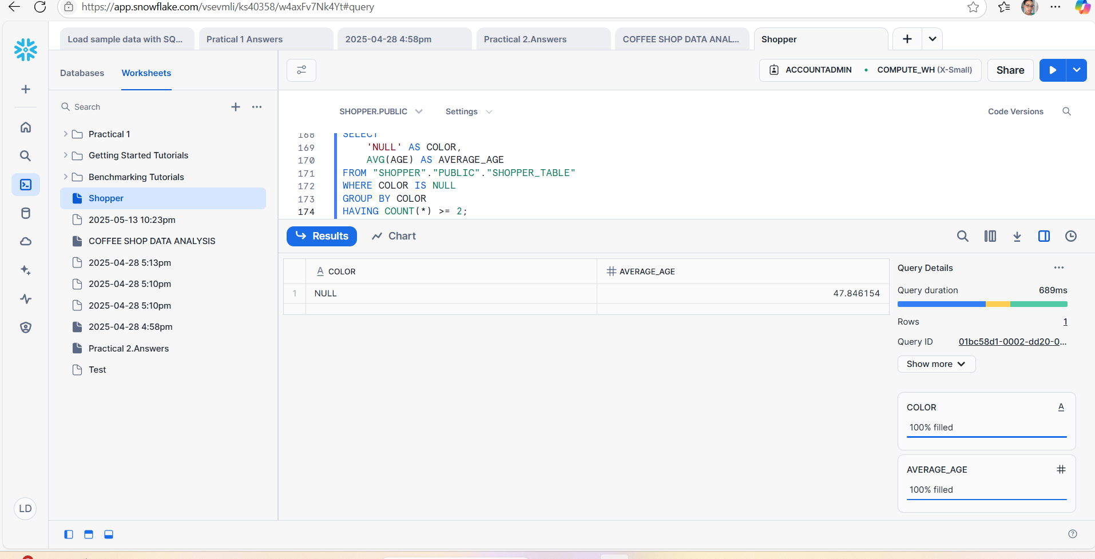

17. Using CASE to create a column Delivery Speed: 'Fast' if Shipping Type is 'Express' or 'Next Day Air', 'Slow' if 'Standard', 'Other' for all else including NULL. Then count how many customers fall into each category.

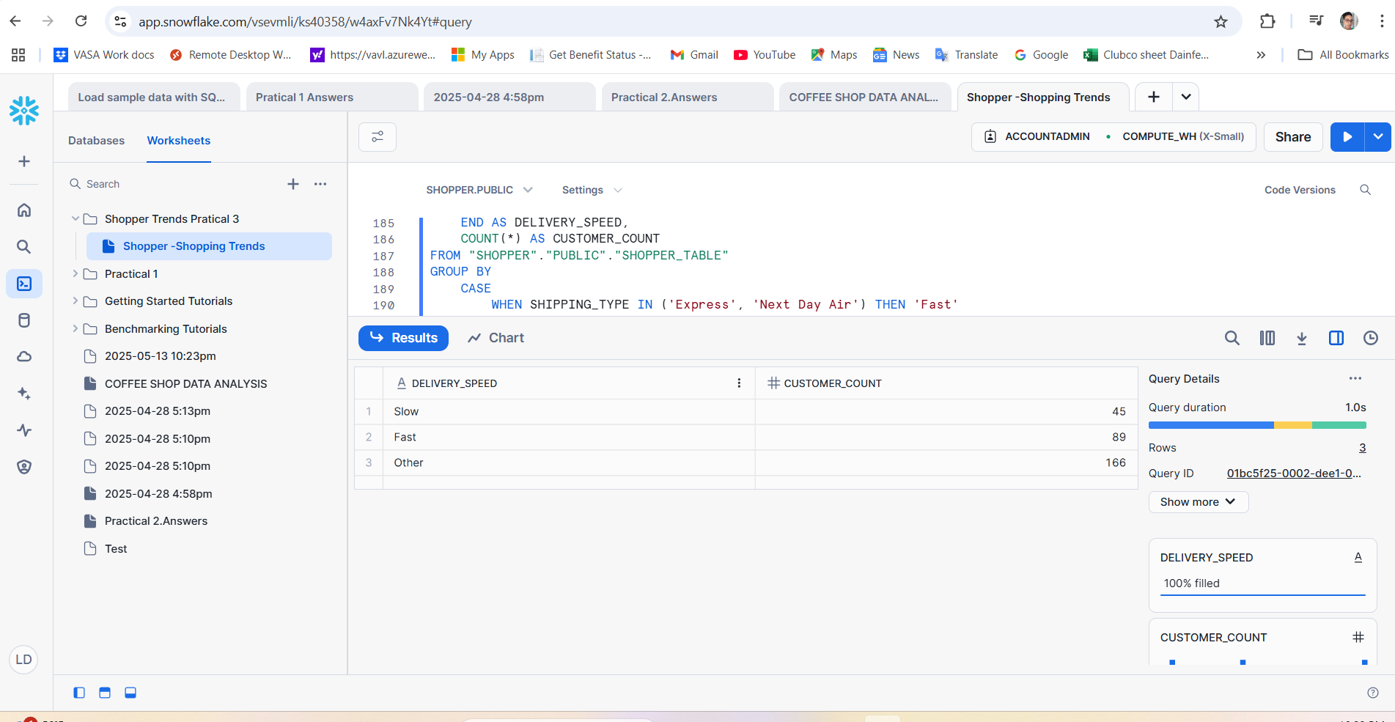

18.. Find customers whose purchase_amount is NULL and whose Promo Code Used is 'Yes'.

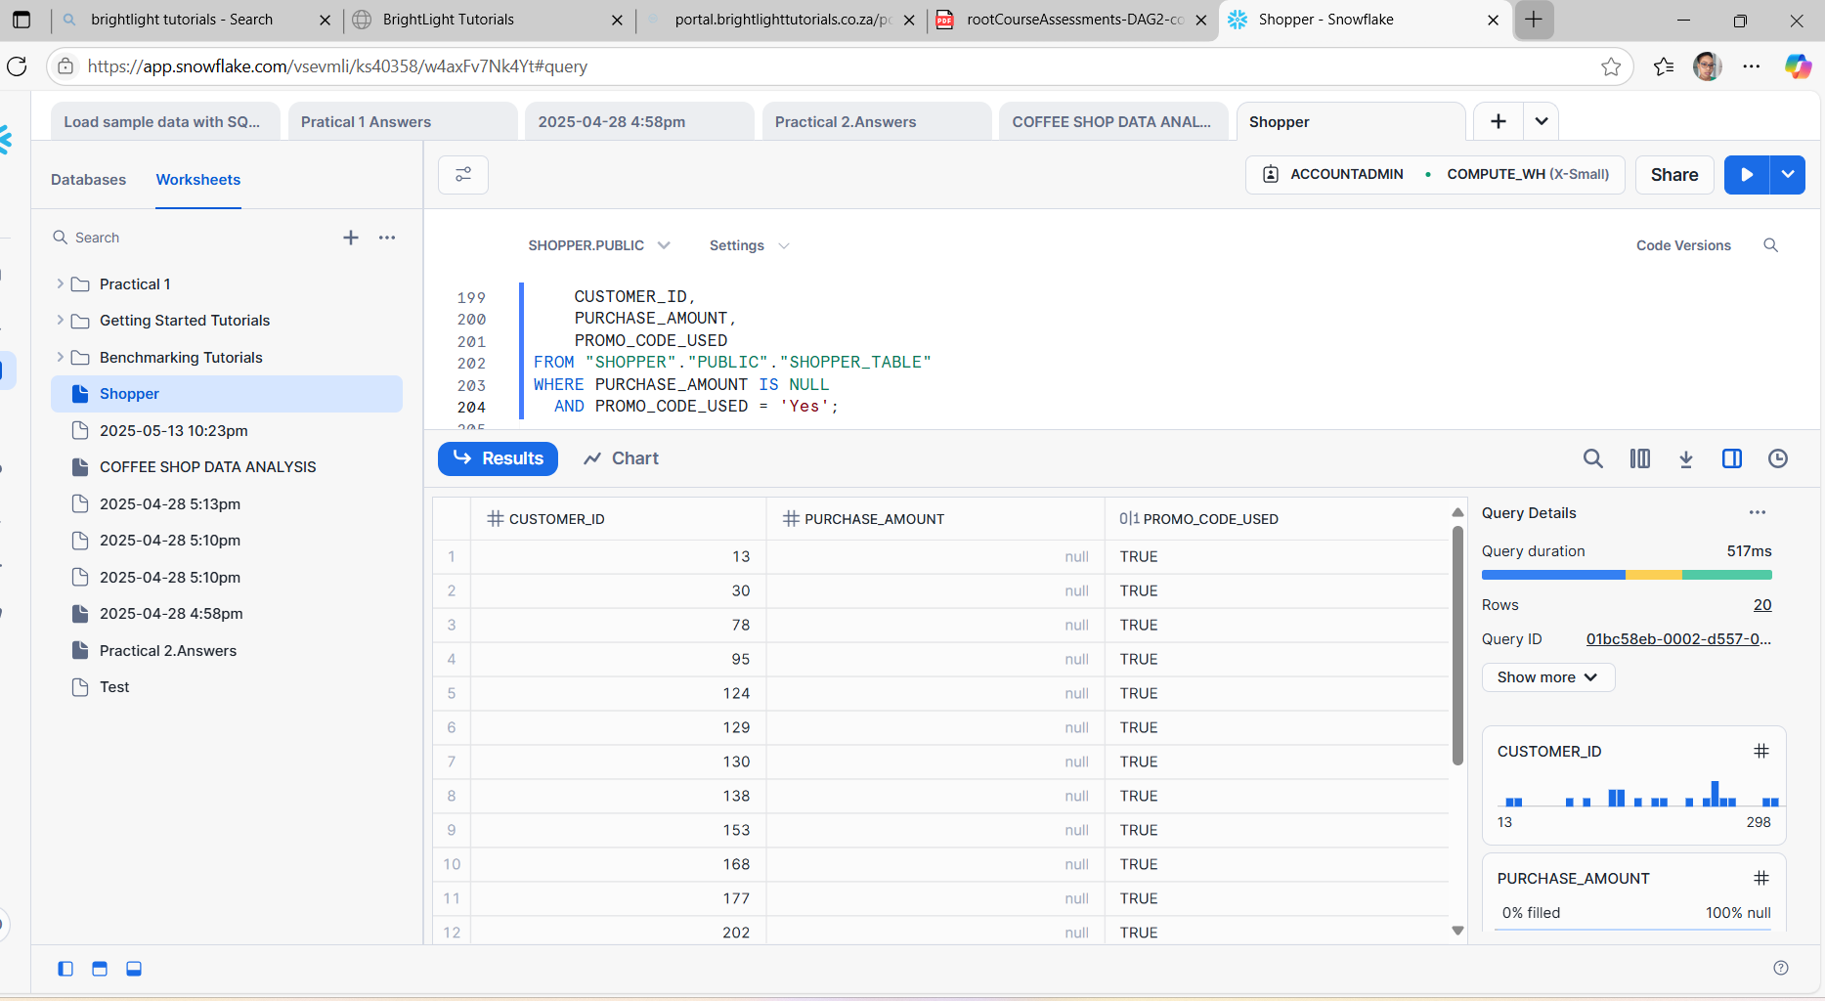

19. Group by Location and show the maximum Previous Purchases, replacing NULLs with 0, only where the average rating is above 4.0.

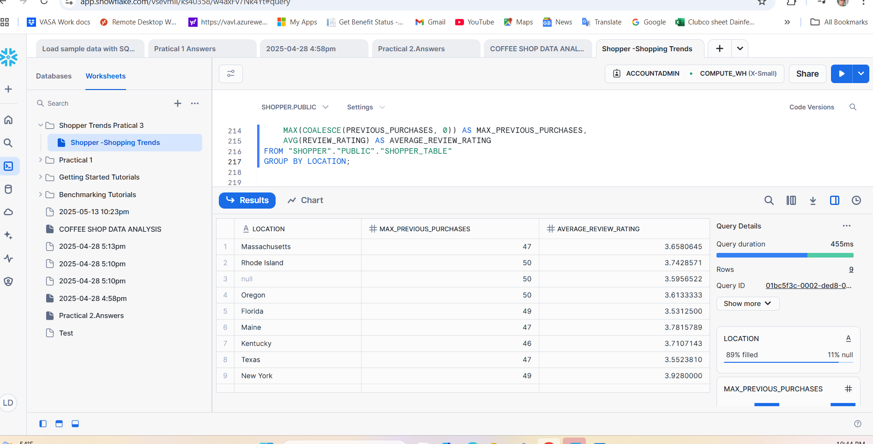

20. Customers who have a NULL Shipping Type but made a purchase in the range of 30 to 70 USD

